**SafeSignal**

Senior Project

by

**Mohamad Awada,**

**Ali Choucair**

Submitted to the School of Engineering of the

Lebanese International University

Beirut, Lebanon

in partial fulfillment of the requirements for the degree of

**BACHELOR OF SCIENCE IN COMMUNICATION ENGINEERING**

**Spring 2023-2024**

**Approved by:**

**Supervisor**  

Dr. Mahdi Saleh



**Committee Member**

Dr. TBA



**DEDICATION**

To someone I know and I care for

In memory of my mother, who shared her love of learning and passion for education with me. She taught me to continue down her path and make a difference by spreading my knowledge. She has taught me that life is about learning, about finding new and better ways to educate others so that they might live their best lives possible. I am dedicating this project to her because it would not be what it is today without her support, encouragement, and guidance over these past years. Thank you, Mom!

I cannot forget my gratitude to my professors Mahdi Saleh and academic advisors who have guided and inspired me throughout my academic career. Your knowledge, expertise, and mentorship have been invaluable in shaping my academic and professional goals.

Mohamad Awada

To someone I know and I care for

Jane D. Doe

**ACKNOWLEDGMENT**

We extend our deepest gratitude to our supervisor, Mahdi Saleh, whose guidance and expertise were instrumental throughout the course of our project. Our thanks also go out to the dean, Amin Haj Ali, whose leadership and support have been invaluable. We are equally thankful to all those who dedicated their time and effort, sparing no resource, to assist us at various stages of this endeavor. Their collective contributions have not only facilitated our research but also enriched our learning experience, for which we are profoundly grateful.

**ABSTRACT**

The abstract goes here with double space 12pt font. The abstract consists of one paragraph with first line indentation. The page should be numbered. The abstract goes here with double space 12pt font. The abstract consists of one paragraph with first line indentation. The page should be numbered. The abstract goes here with double space 12pt font. The abstract consists of one paragraph with first line indentation. The page should be numbered. The abstract goes here with double space 12pt font. **The abstract consists of one paragraph with first line indentation**. The page should be numbered. The abstract goes here with double space 12pt font. The abstract consists of one paragraph with first line indentation. The page should be numbered.

**TABLE OF CONTENTS**

CHAPTER 1 INTRODUCTION 1

1.1 Background 1

1.2 Problem Statement 2

1.3 General overview of the project 3

1.4 Thesis Outline 5

CHAPTER 2 Survey of Existing Methods and Similar Systems 7

2.1 Introduction 7

2.2 System 1: Salt Lake Tow Truck Service 8

2.3 System 2: Fast Auto Services & Transport 9

2.4 System 3: Seattle Towing Services 11

2.5 Methods/Systems Comparison 12

2.6 Conclusion and Motivation 13

CHAPTER 3 System Design 15

3.1 Introduction 15

3.2 Requirements and Specification Analysis 16

3.2.1 Functional Requirements 16

3.2.2 Use Case Diagrams 18

3.3 System Architecture 22

3.4 Class Diagrams 24

3.5 Sequence Diagrams 27

3.6 Activity Diagrams 31

3.7 Entity-Relationship (ER) Diagrams 35

3.8 Non-Technical Aspects 36

3.8.1 Financial Viability 36

3.8.2 Stakeholders 38

3.8.3 Scope 39

3.8.4 Risks 41

3.8.5 Schedule and Milestones 42

3.8.6 Ethical and Social Considerations 43

3.8.7 Environmental and Sustainability Considerations 44

3.8.8 Relevant Standards 45

3.9 Conclusion 46

CHAPTER 4 Implementation/Simulation and Testing 48

4.1 Introduction 48

4.2 Implementation Tools 48

4.3 Implementation Summary 48

1. 48

4.4 Test Cases and Acceptance Criteria 48

4.5 Conclusion 48

CHAPTER 5 Conclusion and Future Work 49

5.1 Conclusion 49

5.2 Future Work 49

**LIST OF FIGURES**

Figure 1 Tow Truck Site 9

Figure 2 Fast Auto Services & Transport 11

Figure 3 Seattle Towing Services 12

Figure 4 Admin Use Case Diagram 19

Figure 5 Employee Use Case Diagram 20

Figure 6 Client Use Case Diagram 21

Figure 7 System Architecture 24

Figure 8 Class Diagrams 26

Figure 9 Admin Interaction Sequence Diagram 27

Figure 10 Employee Interaction Sequence Diagram 28

Figure 11 Client Interaction Sequence Diagram 30

Figure 12 Admin Activity Diagram 32

Figure 13 Employee Activity Diagram 33

Figure 14 Client Activity Diagram 34

Figure 15 SafeSignal System ER Diagram 36

**LIST OF TABLES**

Table 1 Comparison Table Based on Graphical Interfaces 12

Table 2 Comparison Table Based on Content and Functionality 13

Table 3 Comparison Table Based on Features 13

Table 4 Cost Benefit Analysis 37

Table 5 Scheduling Tasks and Milestones 43

**LIST OF SYMBOLS**

MUST LISTED IN ASCENDING ALPHABETICAL ORDER. Examples:

CD: Compact Disk

ISO: International Standardization Organization

LCD: Liquid Crystal Display

LIU: Lebanese International University

Wi-Fi: Wireless Fidelity

# INTRODUCTION

## Background

Urban mobility is an integral aspect of modern living, shaping the dynamics of our daily routines. With the ever-increasing challenges of traffic congestion, parking woes, and the need for efficient transportation, there arises a demand for innovative solutions to enhance urban mobility.

In recent times, the quick pace of urban expansion and rising populations have put additional pressure on city transportation networks. This has resulted in longer travel times and increased dissatisfaction among residents. To address these issues, numerous initiatives have been undertaken to transform urban transportation by implementing innovative technology solutions. [1]

In Lebanon, the situation is particularly acute due to rapid urbanization and population growth, which have placed significant strain on the country's transportation systems. The Lebanese context presents unique mobility challenges characterized by congested urban centers, inadequately developed public transportation infrastructure, and a high reliance on personal vehicles. A study by the World Bank highlighted that traffic congestion in Beirut alone costs the economy up to USD 2 billion annually, amounting to almost 4% of the country's GDP [2]. Moreover, the lack of efficient public transport options exacerbates the situation, leading to increased vehicle ownership rates, with statistics indicating there are more cars per capita in Lebanon than the global average [3].

Recognizing these challenges, there has been a growing interest in Lebanon to revolutionize urban mobility through technological interventions. However, the advent of ride-sharing applications, smart parking solutions, and on-demand transportation services has marked a significant shift in addressing urban mobility issues. These solutions, however, often operate independently, lacking a cohesive framework that holistically caters to diverse transportation needs. [4]

This senior project aims to bridge this gap by proposing an integrated SafeSignal System. Drawing inspiration from existing models and addressing their limitations, our system aspires to provide a seamless, all-encompassing solution to urban mobility challenges.

## Problem Statement

This section a formal statement of the thesis problem must be clearly defined. The problem statement must include a detailed reformulation of the topic definition originally presented by the supervisor. This section should not span more than two to three pages.

Please respect indentation of each new paragraph.

Urban centers worldwide grapple with the intricate challenges of transportation inefficiencies, traffic congestion, and limited parking availability [5]. As cities continue to expand and populations surge, these issues intensify, impacting the quality of life for residents and impeding the overall efficiency of urban mobility [6].

Existing transportation solutions, though innovative, often operate in isolation, lacking a unified approach to address the multifaceted problems associated with urban mobility. Ride-sharing platforms, parking assistance apps, and driving lesson services function as fragmented entities, contributing to a disjointed urban transportation landscape.

The absence of an integrated system exacerbates the following key problems:

* **Traffic Congestion:** Uncoordinated transportation services lead to increased traffic congestion, elongating commute times and elevating stress levels for city commuters.
* **Parking Challenges:** Finding suitable parking spaces during peak hours becomes a cumbersome task, contributing to traffic bottlenecks and wasted time.
* **Skill Development Gap:** Aspiring drivers face challenges in accessing convenient and reliable driving lesson services, hindering the development of essential driving skills.

To address these issues, there is an imperative need for a comprehensive SafeSignal System that seamlessly integrates various services. This system should not only optimize traffic flow and parking solutions but also facilitate skill development through accessible driving lessons.

This project aims to formulate an innovative solution that unifies these disparate aspects of urban mobility, offering a holistic approach to transportation challenges faced by city residents.

## General overview of the project

SafeSignal is a mobile application designed to revolutionize urban mobility and transportation services. Focused on addressing common issues faced by urban commuters and vehicle owners, SafeSignal offers a suite of services tailored to enhance efficiency, reliability, and satisfaction in navigating urban environments. The application encompasses the following key services:

* **Motorcycle Assistance Service:** Tailored for users caught in heavy traffic, this service offers a swift solution by dispatching team members on motorcycles. These professionals assist users in navigating through congested areas, significantly reducing travel time and improving the overall commuting experience.
* **Car Towing:** In scenarios where vehicles cannot be immediately repaired or are unsafe to drive, SafeSignal provides a car towing service. Users can request towing assistance directly through the app, ensuring quick response and peace of mind in stressful situations.
* **Roadside Support Service:** SafeSignal provides extensive support for individuals facing vehicle malfunctions. Our service teams are prepared to manage everything from small fixes to essential aid directly where the breakdown occurs, ensuring that users regain their mobility and peace of mind swiftly.
* **Fuel Delivery Service:** Addressing the common predicament of running low on fuel, SafeSignal enables users to request fuel delivery anywhere within the covered urban area. A dedicated team member delivers the necessary fuel directly to the user's location, ensuring uninterrupted travel and convenience.

The SafeSignal app is designed with a user-friendly interface, allowing for easy access to all services with just a few taps. Users can request assistance, track service provider arrival in real time, and complete transactions securely within the app. By integrating these services into a single platform, SafeSignal aims to provide a seamless, all-encompassing solution to urban transportation challenges, fostering a more sustainable and efficient mobility ecosystem.

This overview provides a snapshot of what users can expect from SafeSignal, setting the stage for a deeper exploration of each service in the following chapters. Our commitment to innovation, user satisfaction, and reliability drives the development of SafeSignal, promising a transformative impact on urban mobility.

## Thesis Outline

This thesis is structured into five chapters, with each one focusing on a different stage in the development and evaluation of the SafeSignal System:

* **Chapter 1: Introduction** - This opening chapter sets the stage for our exploration of urban mobility challenges. It articulates the problem statement, highlights the objectives of the SafeSignal System, and underscores the necessity for an innovative solution to navigate the complexities of urban transportation.
* **Chapter 2: Survey of Existing Methods and Similar Systems** - Venturing into the landscape of existing urban mobility solutions, this chapter dissects various methodologies and systems previously or currently in use. Through a detailed examination, it seeks to uncover their strengths and weaknesses, offering a comprehensive perspective on the effectiveness of these approaches.
* **Chapter 3: System Design** - At the heart of this thesis, the SafeSignal System is introduced in detail. From its conception to a meticulously structured blueprint, this chapter delves into the system's design, covering both functional and non-functional elements such as financial viability, stakeholder engagement, project scope, potential risks, and ethical considerations. This foundational chapter provides a clear roadmap for the system's architectural and operational framework.
* **Chapter 4: Implementation/Simulation and Testing** - This chapter walks through the technical execution of the SafeSignal System, detailing the selection of implementation tools, the development process, and the integration of various components. It transitions into the critical phase of testing, where test cases and acceptance criteria are elaborated upon to ensure the system's functionality and reliability meet the set standards.
* **Chapter 5: Conclusion and Future Work** - The thesis culminates with reflections on the journey of the SafeSignal System project. Summarizing its impacts and contributions to addressing urban mobility challenges, this chapter not only encapsulates the key findings and lessons learned but also casts an eye toward future developments. It explores potential avenues for enhancing and expanding the system, laying the groundwork for ongoing innovation in urban mobility solutions.

This structure ensures a logical flow and comprehensive coverage of the project, from the initial concept through to future possibilities, underscoring the SafeSignal System's role in transforming urban mobility.

# Survey of Existing Methods and Similar Systems

## Introduction

In the complex weave of modern life, urban mobility emerges as a pivotal aspect, marked by the dual challenges of navigating traffic congestion and enhancing the efficiency of transportation solutions. This chapter embarks on an in-depth exploration of the myriad methods and systems developed to confront these challenges. By venturing into the landscape of current urban mobility solutions, our objective is to unearth the strengths and shortcomings of a variety of approaches. This examination will span a broad spectrum of methods implemented across different countries, each contributing uniquely to the realm of urban mobility.

As we progress through this chapter, our analysis will focus on dissecting the nuances of diverse systems, examining their functionalities, and evaluating their effectiveness in addressing urban mobility issues. From the traditional to the technologically advanced, each method paints a part of the broader picture of urban mobility. This survey aims not only to highlight existing solutions but also to lay the groundwork for the introduction of a novel approach in subsequent chapters - the SafeSignal System.

Our narrative will also shed light on whether such integrated systems exist in Lebanon, recognizing the unique challenges and opportunities within the local context. Notably, the absence of a comprehensive system in Lebanon that mirrors the proposed SafeSignal System underscores the transformative potential of our project.

Through this comprehensive survey, we aim to build a foundation for a comparative assessment that not only catalogs existing methods but also critically analyzes their application and impact. As such, this chapter is a precursor to the innovative strides we propose with the SafeSignal System, marking a significant leap forward in tackling the intricacies of urban mobility with technology at its core.

## System 1: Salt Lake Tow Truck Service

The Salt Lake Tow Truck Service [7] stands as a notable SafeSignal system with a primary focus on providing towing and roadside assistance services. Established to address vehicular breakdowns, accidents, and other emergency situations, this system caters to individuals facing unexpected challenges on the road. Refer to Figure 1.

* + **Common Features:**
    - **24/7 Emergency Towing:** Salt Lake Tow Truck Service operates round the clock, ensuring users have access to emergency towing services whenever needed.
    - **Roadside Assistance:** In addition to towing, the system offers roadside assistance, including jump-starts, tire changes, and fuel delivery, contributing to a comprehensive support system for drivers.
    - **User-Friendly Request System:** The platform provides an easy-to-use online request system, allowing users to request assistance efficiently through their website or contact number.

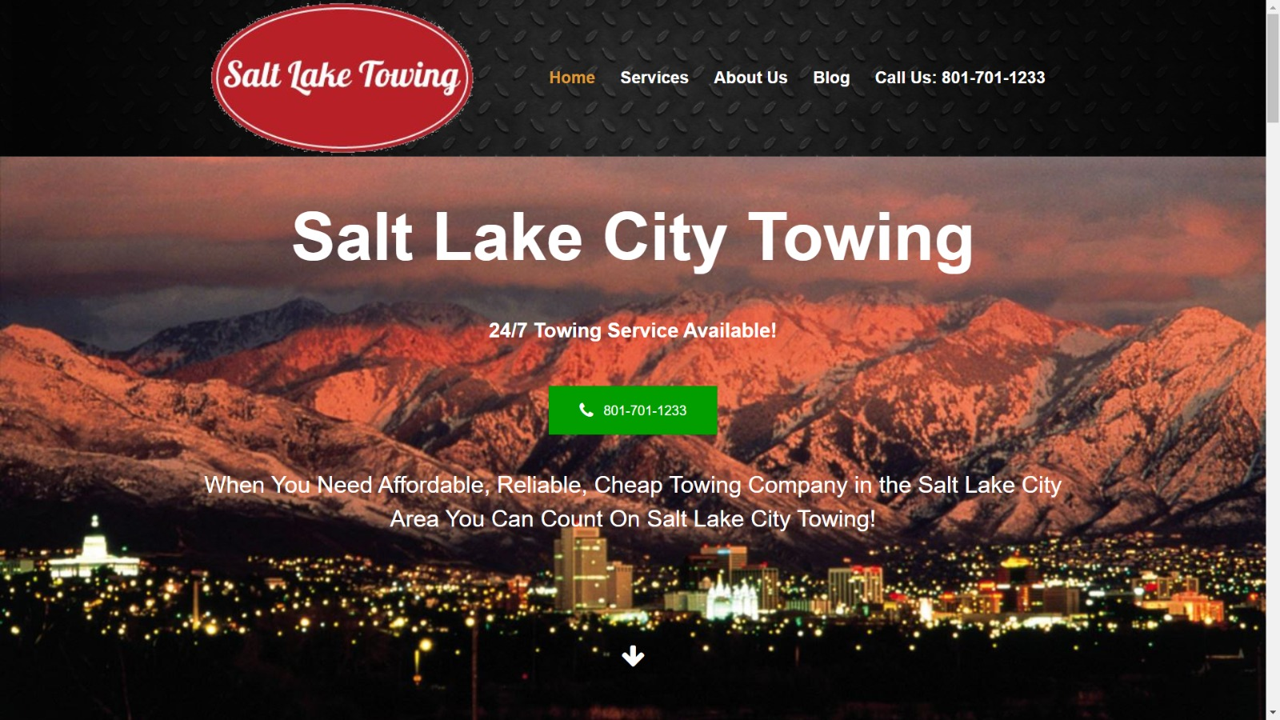

Figure 1 Tow Truck Site

## System 2: Fast Auto Services & Transport

Fast Auto Services & Transport [8] is a prominent SafeSignal system operating in Lebanon, known for its wide array of towing and roadside help services specifically designed for the demands of drivers in Lebanon. Prioritizing quick service and client contentment, their platform delivers a smooth process for those in need of aid. They feature an easy-to-navigate website interface, making it straightforward for users to request services. See Figure 2.

* + **Common Features:**
    - **Prompt Response Time:** Echoing the emphasis on swift service delivery, Fast Auto Services & Transport prides itself on rapid response times, ensuring users receive timely assistance to mitigate the inconvenience of vehicle breakdowns.
    - **Wide Range of Roadside Assistance Services:** The system extends beyond simple towing services to include a broad spectrum of roadside assistance solutions, such as jump-starts, tire changes, fuel delivery, and lockout services, providing users with comprehensive support in various scenarios.
    - **Transparent Pricing:** Fast Auto Services & Transport adheres to a policy of transparent pricing, guaranteeing that users are fully informed about the cost of services beforehand, which fosters trust and enhances customer satisfaction.
    - **24/7 Service Availability**: Recognizing the unpredictable nature of vehicular troubles, the platform ensures that assistance is available around the clock, underscoring the system's reliability and dedication to user safety.
    - **Intuitive Website Design:** The website is crafted to prioritize the user, incorporating a straightforward navigation setup that enables individuals to easily seek the support they require, thus enhancing the overall user experience.

By introducing Fast Auto Services & Transport as a viable solution within the Lebanese context, this analysis not only highlights the current state of roadside assistance and towing services in the region but also underscores the potential for technological and service enhancements. This comparison sets the stage for the introduction of the SafeSignal System, proposing a forward-looking solution to Lebanon's urban mobility challenges.

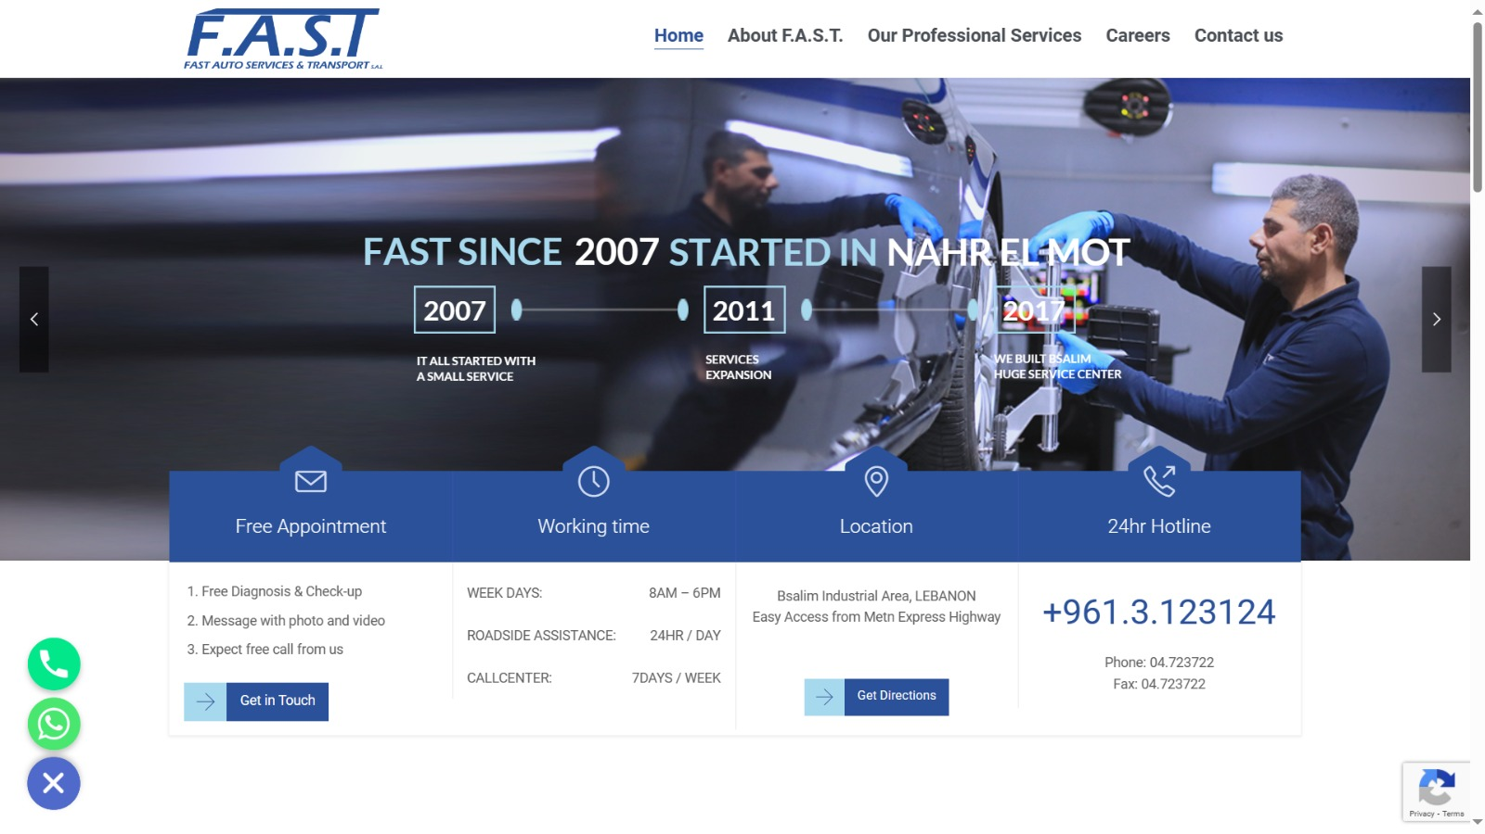

Figure 2 Fast Auto Services & Transport

## System 3: Seattle Towing Services

Seattle Towing Services [9] is a comprehensive SafeSignal system serving the Seattle metropolitan area. With a primary focus on towing and recovery, the platform (Refer to Figure 3) distinguishes itself by offering specialized solutions for different vehicle types and situations. Similar to the previously mentioned systems, it addresses the challenges faced by drivers in Seattle, providing timely and reliable assistance.

* + **Common Features:**
    - **Specialized Towing Solutions:** Seattle Towing Services goes beyond standard towing, providing specialized solutions for a variety of vehicles, including cars, motorcycles, and larger vehicles like trucks and RVs.
    - **Diverse Service Offerings:** In addition to towing, the platform extends its services to vehicle recovery, impounding, and vehicle relocation. This diverse range of offerings provides users with a comprehensive suite of solutions.

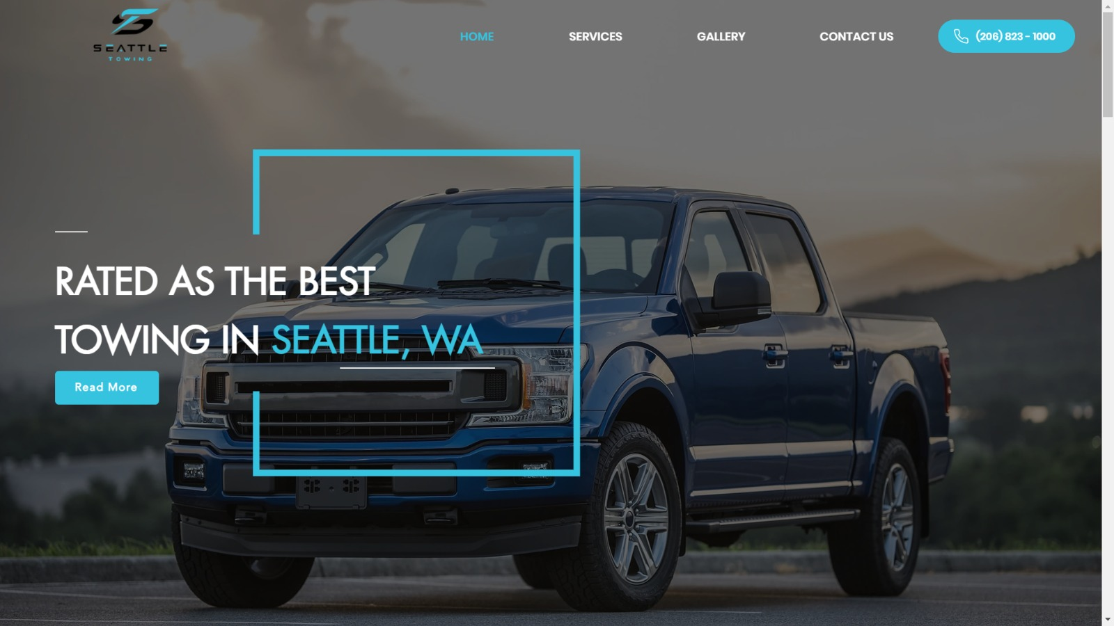

Figure 3 Seattle Towing Services

## Methods/Systems Comparison

This section provides a comprehensive comparison of the three aforementioned SafeSignal systems. The evaluation is based on key criteria related to graphical interfaces, content and functionality, and features.

|  |  |  |  |
| --- | --- | --- | --- |
| **Criterion 1** | **System 1** | **System 2** | **System 3** |
| **Graphical Interface** |
| Good user interface |  |  |  |
| Easy and effective navigation |  |  |  |
| Simple and professional Design |  |  |  |
| Responsive |  |  |  |

Table 1 Comparison Table Based on Graphical Interfaces

|  |  |  |  |
| --- | --- | --- | --- |
| **Criterion 2** | **System 1** | **System 2** | **System 3** |
| **Content and Functionality** |
| Quality content structure |  |  |  |
| Usability |  |  |  |
| Dynamic content |  |  |  |
| Content management system |  |  |  |

Table 2 Comparison Table Based on Content and Functionality

|  |  |  |  |
| --- | --- | --- | --- |
| **Criterion 3** | **System 1** | **System 2** | **System 3** |
| **Features** |
| Security measures |  |  |  |
| Third party integration |  |  |  |
| Accessible content and location |  |  |  |
| Registration form |  |  |  |

Table 3 Comparison Table Based on Features

## Conclusion and Motivation

In conclusion, the comparison of existing SafeSignal systems, reveals valuable insights into their strengths and weaknesses. The evaluation across graphical interfaces, content functionality, and features underscores the need for a more comprehensive and integrated solution.

While all three systems exhibit commendable graphical interfaces and essential features, certain limitations are evident. System 1 lacks dynamic content and a content management system, potentially hindering adaptability and updates. System 2 and System 3 outshine in these aspects but fall short in third-party integration, a crucial element for expanding services and user convenience.

The motivation for our work stems from addressing these gaps and providing a holistic SafeSignal system. The newly proposed SafeSignal System aims to amalgamate the strengths of existing systems, offering a user-friendly interface, dynamic content management, robust security measures, and seamless third-party integration. By doing so, our system intends to overcome the limitations observed in the evaluated systems, providing an all-encompassing solution for urban mobility challenges.

# System Design

## Introduction

In this critical chapter of our exploration, we delve into the architectural essence and intricate design mechanisms of the SafeSignal System. Here, we construct the backbone of our proposed solution, meticulously outlining the comprehensive framework that empowers our system to address the nuanced challenges of urban mobility and roadside assistance with unprecedented efficiency and user-centric precision.

Drawing upon the insights gleaned from the evaluation of existing systems, as illustrated in Chapter 2, we proceed to sculpt our innovative approach. This journey into the System Design of SafeSignal is partitioned into detailed segments, each dedicated to unveiling a layer of our system's architecture. We start by articulating the core requirements and specifications that guide the development trajectory of SafeSignal. This is followed by a visual and analytical dissection of our system through Use Case Diagrams, revealing the dynamic interactions between the users and SafeSignal.

Further, we present the System Architecture, offering a bird's eye view of the structural blueprint that orchestrates the seamless operation of our system. Complementing this architectural overview, we examine the Class and Sequence Diagrams, which detail the object-oriented composition and operational chronology within SafeSignal, respectively. Activity and Entity-Relationship Diagrams enrich this exploration by mapping the procedural flow and database schema that underpin our system’s functionality.

Venturing beyond the technical scaffold, this chapter also contemplates the Non-Technical Aspects integral to the realization of SafeSignal. From Financial Viability and Stakeholder Analysis to Ethical Considerations and Environmental Impact, we ensure a holistic design perspective that aligns with our vision of sustainable and socially responsible urban mobility solutions.

As we navigate through this chapter, our aim is not just to elucidate the design of SafeSignal but to weave a narrative that underscores our commitment to innovation, user empowerment, and the relentless pursuit of excellence in urban mobility.

## Requirements and Specification Analysis

This section delves into the foundational elements of the SafeSignal System, laying out the detailed specifications, documentation, and functional requirements crucial for its operation. Through careful analysis and design, we ensure that SafeSignal not only meets but exceeds the expectations of its users, offering a robust, intuitive, and comprehensive solution for urban mobility challenges.

### Functional Requirements

The functional requirements of the SafeSignal System define the core operations and activities it must perform to effectively serve its users. These requirements are derived from an understanding of user needs, market research, and the analysis of existing systems discussed in Chapter 2. Each requirement is geared toward providing a seamless, efficient, and reliable user experience.

* + **User Registration and Authentication:**
    - Users can create and manage their accounts using an email address.
    - The system provides secure authentication mechanisms, including password recovery.
  + **Service Request Submission:**
    - Users can request roadside assistance services, through the app.
    - The system allows users to specify their location via GPS or manual entry, select the type of service needed, and provide additional details if necessary.
  + **Real-time Service Tracking:**
    - Upon service request submission, users can track the status of their request and the estimated arrival time of the service provider in real time.
  + **Transaction Handling:**
    - The platform employs reliable payment gateways for the secure processing of payments for services provided.
    - It offers various payment methods, allowing users to pay through credit/debit cards, electronic wallets, and cash upon service delivery.
  + **Ratings and Feedback:**
    - After service completion, users can rate the service provided and leave feedback to help improve service quality and user satisfaction.
  + **Assistance and Resources:**
    - The platform includes a built-in knowledge center featuring FAQs, safety advice, and guides for users.
    - Customer support is available through chat or email, providing help or addressing any concerns users might have.
  + **Service Provider Interface:**
    - Service providers have access to a separate portal or app interface where they can manage service requests, update status, navigate to user locations, and manage payments and ratings.
  + **Admin Dashboard:**
    - The system includes an administrative dashboard for system administrators to manage employees.

These functional requirements are meticulously designed to ensure that the SafeSignal System is comprehensive, user-friendly, and capable of addressing the diverse needs of urban mobility users. The following sections will delve deeper into the system's architecture and design details, illustrating how these requirements translate into a tangible and operational system.

### Use Case Diagrams

Use case diagrams are instrumental in defining and understanding the interactions between users (actors) and the system from a high-level perspective. They depict the range of functions the system offers and how different users engage with these functions. For the SafeSignal System, we've developed three distinct use case diagrams to accurately represent the functionalities accessible to each type of user: Administrators (Admin), Employees, and Persons (Clients).

* + **Admin Use Case Diagram:**

The Admin use case diagram encapsulates the functionalities available to system administrators. This includes managing accounts, Service Providers, Monitor Servires requests, and request help form the closet contracting company.

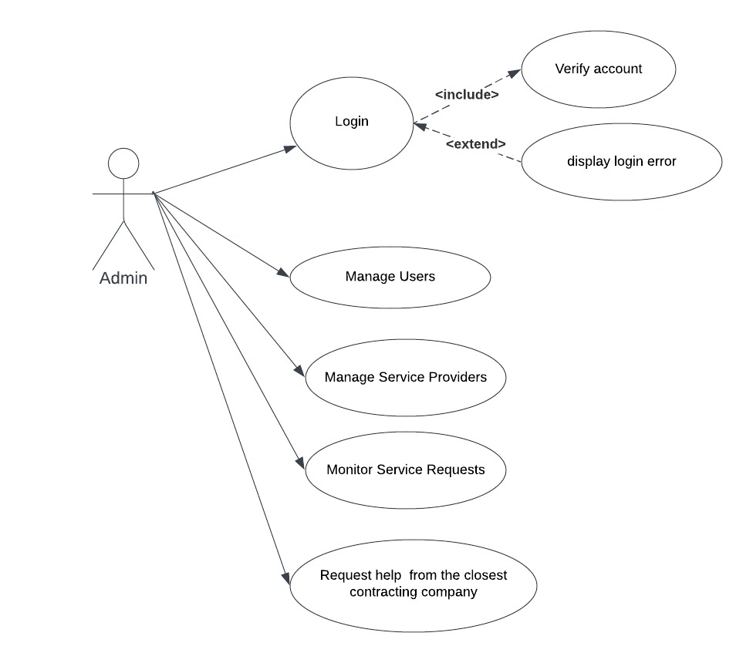

Figure 4 Admin Use Case Diagram

Refer to Figure 4for a detailed illustration of the interactions and functionalities available to system administrators within the SafeSignal System.

* + **Employee Use Case Diagram:**

Employees, such as service providers and support staff, interact with the system to manage service requests, update service statuses, navigate to user locations, and manage their service offerings.

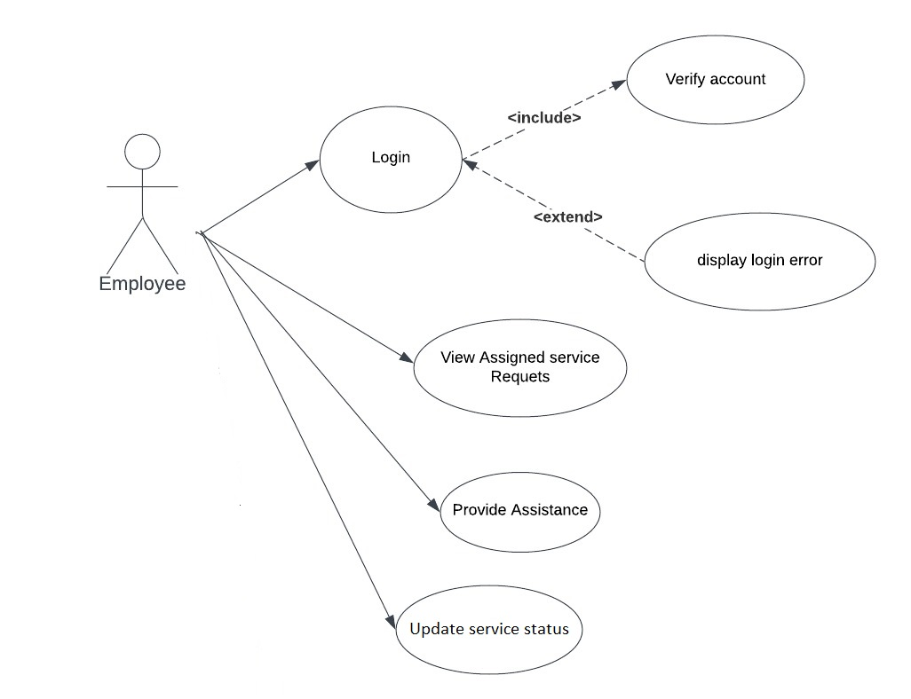

Figure 5 Employee Use Case Diagram

Figure 5 presents a comprehensive view of the employee interactions with the SafeSignal System, highlighting the critical operations they perform to deliver services effectively.

* + **Client Use Case Diagram:**

Clients utilize the system to request services, make payments, and provide ratings and feedback. This diagram emphasizes the client-centric features designed to enhance their experience and satisfaction.

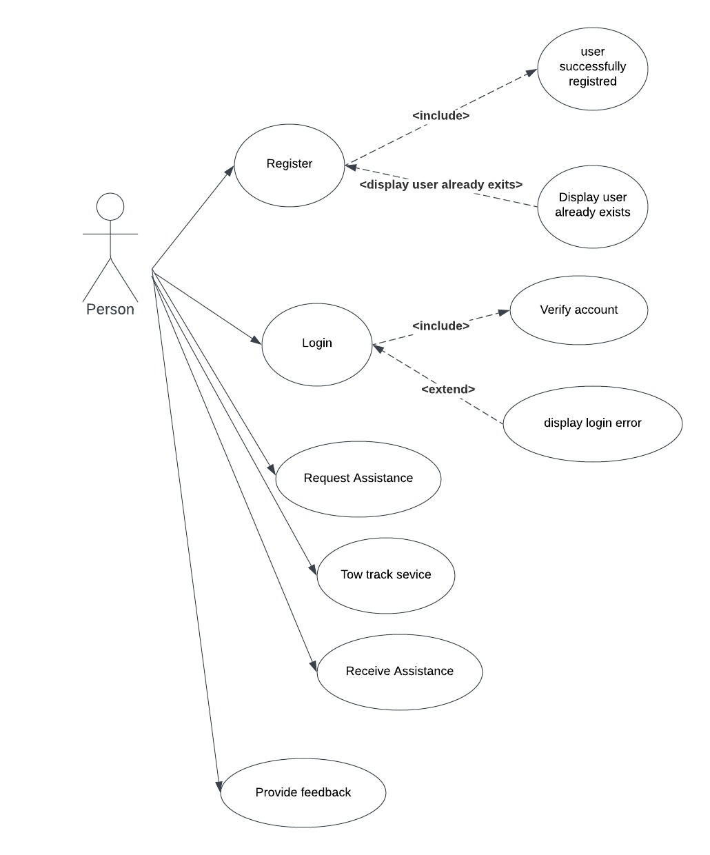

Figure 6 Client Use Case Diagram

For a detailed depiction of the client's interaction with the SafeSignal System, see Figure 6 which outlines the services and functionalities accessible to users.

These use case diagrams serve as a foundational element in the design process, guiding the development team in creating a system that meets the diverse needs of our users. By examining the system from the perspectives of Admins, Employees, and Clients, we ensure a comprehensive and user-centric approach to system development. The diagrams underscore the importance of each user type in the ecosystem of the SafeSignal System, facilitating a clear understanding of their roles and interactions within the platform.

## System Architecture

Define the overall architecture of the system. Layered, Dataflow, Multi-tier, Client-Server, etc. It is worth noting the underlying technologies to be used. Draw a figure that shows the complete system Example of such figures:

The architecture of the SafeSignal System is structured as a multi-tiered setup, primarily focusing on the Android mobile application. This design ensures a clear distinction between user interface processes, business logic, and data management, aligning with the client-server paradigm tailored for mobile environments.

Here is an overview of each component within the system architecture:

* + **Front-end Layer (User Interface):**

The front-end layer is solely responsible for the user interface of the Android application. This layer provides a responsive and intuitive interface that users interact with. It encompasses all client-side operations, including request initiation, service tracking, and user interaction with the application. Utilizing Android's robust framework, the app adapts seamlessly to various screen sizes and device capabilities, allowing for a consistent user experience across different Android devices.

* + **Backend Layer (Server-side):**

The backend is the system's operational core, handling business logic, service coordination, and data processing. It is composed of a server application that runs on a secure environment, designed to process user requests, interact with the database, and perform all necessary computations and state management. The server-side component is responsible for authenticating users, managing service requests, processing payments, and storing transactional and user data.

* + **Database Layer:**

A critical component of the system architecture is the database layer, which is responsible for persistent data storage. It maintains all necessary data, including user profiles, service requests, transaction histories, and feedback.

* + **Integration and Communication:**

The system architecture facilitates seamless integration and communication between the front-end and back-end layers. The Android application communicates with the server, designed to be lightweight, stateless, and scalable.

* + **Safety Features:**

The importance of security is a primary focus in the system's architecture, integrating strong security measures to safeguard important information. This encompasses employing a secure login procedure.

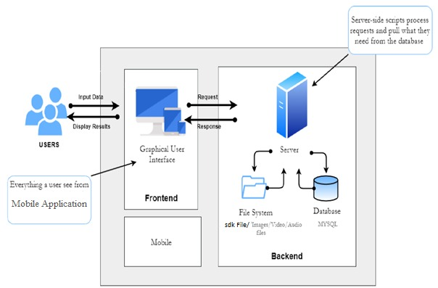

Figure 7 System Architecture

Figure 7 provides a comprehensive view of the SafeSignal System's architecture, illustrating the interplay between the user-facing Android application and the back-end components that support its operations. It underscores the system's design principles, focusing on security, user experience, and a clear separation of functionalities. This architecture ensures that the SafeSignal Android application delivers robust performance, high reliability, and a seamless service experience for all users.

## Class Diagrams

The class diagram for the SafeSignal application acts as a foundational blueprint for the system's object-oriented design, detailing the class hierarchy and the interrelations among the various classes that constitute the system. This diagram is pivotal for understanding the static structure of the application, guiding the development process through a clear representation of the system's architecture.

* + **Admin Class:**

Key to managing the system, the Admin class stores essential login credentials (email and password) and supports various administrative functions. These functions encompass:

* + - **Login**: Authenticates administrative access.
    - **Manage Users**: Controls user account management.
    - **Manage Service Providers**: Oversees service provider activities.
    - **Monitor Service Requests**: Tracks and manages service requests.
    - **Request help**: Demonstrates the ability of admins to request assistance from the closest contracting company.
  + **Employee Class:**

Structured similarly to the Admin class but tailored for service provider personnel, the Employee class facilitates service delivery within the SafeSignal ecosystem. Its primary functions include:

* + - **Login**: Authenticates employee access.
    - **View Assigned Service Requests**: Shows service requests assigned to the employee.
    - **Provide Assistance**: Records the assistance provided to users.
    - **Update Service Status**: Modifies the status of active services.
  + **Person Class:**

As the base class for system users, the Person class contains fields for login credentials and supports methods that enable user interaction with the SafeSignal system, such as:

* + - **Register**: Allows new users to set up an account.
    - **Login**: Enables user login.
    - **Request Assistance**: Permits users to initiate assistance requests.
    - **Receive Assistance**: Facilitates receipt of service provider assistance.
    - **Provide feedback:** Collects user feedback on services received.

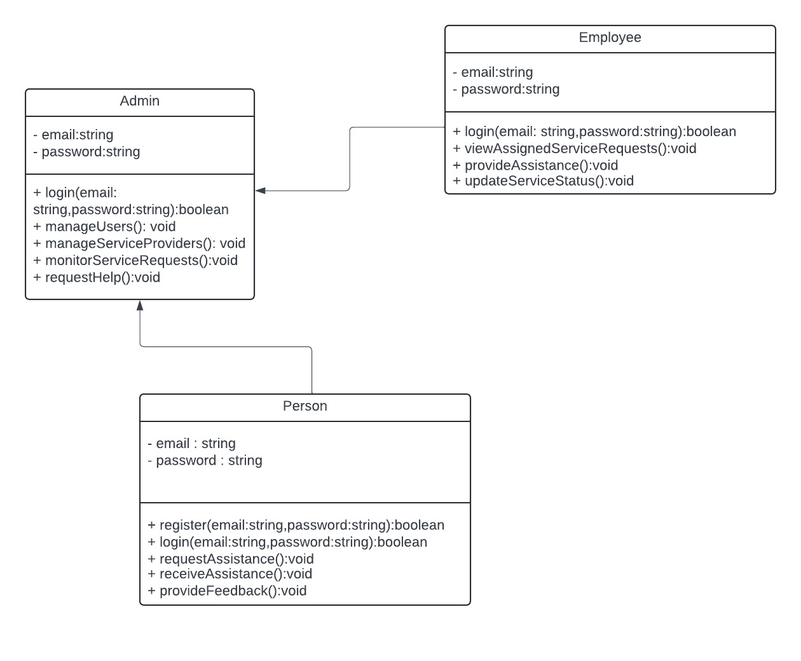

Figure 8 Class Diagrams

This class diagram (Figure 8) provides a visual representation of the core structural components of the SafeSignal application. It offers a high-level understanding of how the system is organized and the way different classes interact with one another. By detailing the attributes and operations of each class, developers and stakeholders can gain insights into the application's design and how it facilitates the overall functionality of the SafeSignal service.

## Sequence Diagrams

Sequence diagrams play a crucial role in elucidating the dynamic behavior of the SafeSignal System, illustrating how different entities interact over time to accomplish specific tasks. By delineating the sequence of operations and the flow of messages between the system's components and users, these diagrams offer into the procedural logic underpinning the system's functionality. For the SafeSignal System, we have meticulously developed three sequence diagrams to represent the distinct interactions involving Persons (Clients), Admins, and Employees.

* + **Admin Interaction Sequence Diagram:**

The Admin interaction sequence diagram focuses on the administrative tasks within the system, such as managing accounts. It highlights the admin's role in maintaining the system's integrity and ensuring smooth operation through proactive management and oversight.

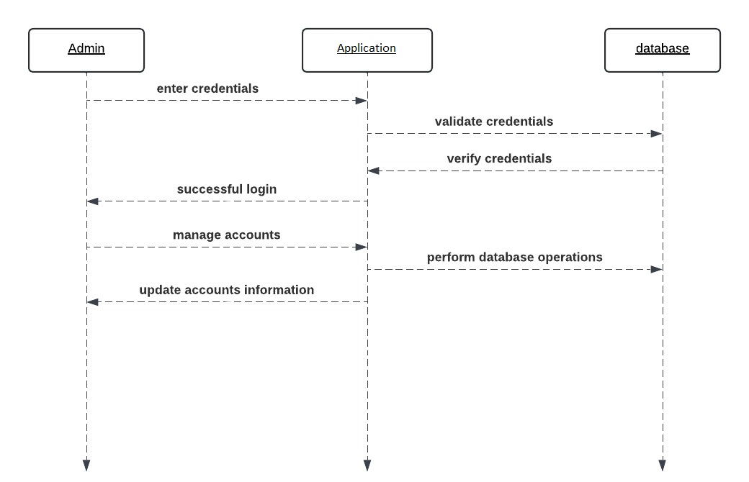

Figure 9 Admin Interaction Sequence Diagram

Figure 9 demonstrates the order of operations and message flow that typify the administrative interactions within the SafeSignal System.

* + **Employee Interaction Sequence Diagram:**

Employees, encompassing service providers and support staff, interact with the system to manage and fulfill service requests. This diagram details the sequence of events from the reception of a service request through to its execution and status update, encapsulating the operational workflow that enables employees to deliver services efficiently.

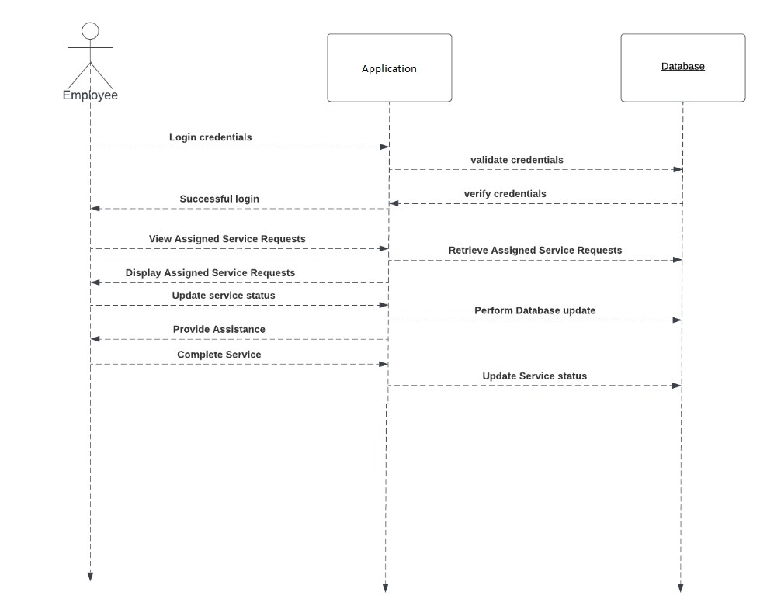

Figure 10 Employee Interaction Sequence Diagram

For a detailed account of the sequential interactions involving employees, see Figure 10, showcasing how they navigate the SafeSignal System to provide timely and effective services.

* + **Client Interaction Sequence Diagram:**

This diagram illustrates the sequence of interactions initiated by a client, from service request submission through to service completion and feedback submission. It captures the client's engagement with the system, detailing the flow of messages for requesting assistance, receiving confirmations, tracking service status, and providing ratings or feedback upon service completion.

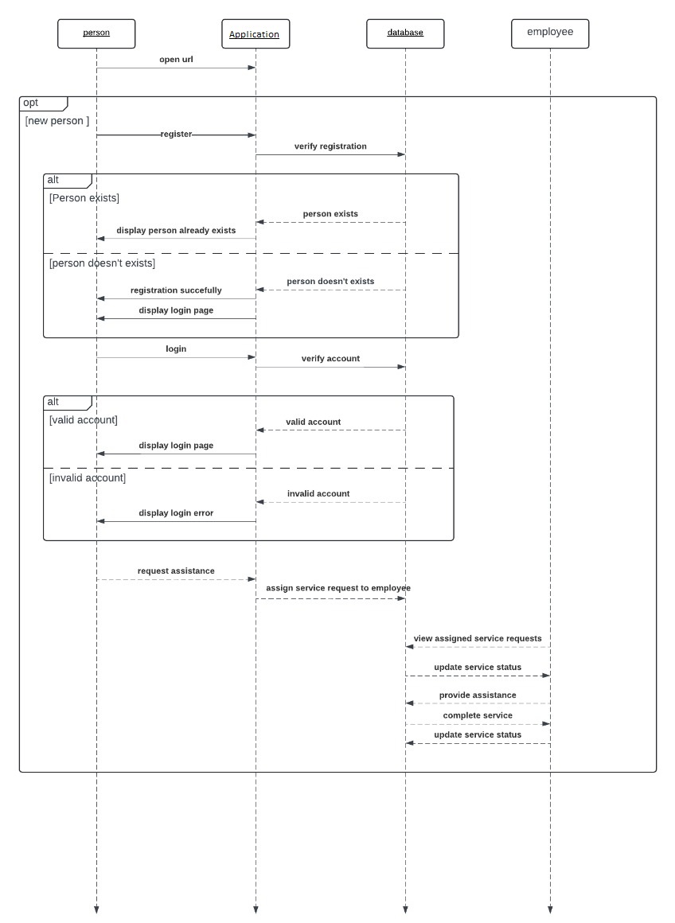

Figure 11 Client Interaction Sequence Diagram

Refer to Figure 11 for a visual representation of the chronological sequence of interactions a client undergoes within the SafeSignal System.

Through these sequence diagrams, we offer a detailed exploration of the temporal interactions that define the user experience and operational efficiency of the SafeSignal System. By dissecting the interactions specific to Clients, Admins, and Employees, we ensure a holistic understanding of the system's dynamics, paving the way for a design that is both user-centric and operationally robust.

## Activity Diagrams

Activity Diagrams are employed to detail the procedural flow of operations within the SafeSignal System, illustrating how various activities are coordinated to achieve the desired outcomes. These diagrams are instrumental in visualizing the system's functionality at different abstraction levels, providing insights into the coordination required among distinct operations. We have developed three activity diagrams to encapsulate the processes for clients, admins, and employees.

* + **Admin Activity Diagram:**

This diagram portrays the activities administered by system administrators, including managing accounts, monitoring service providers, and requesting help from the closest contracting company.

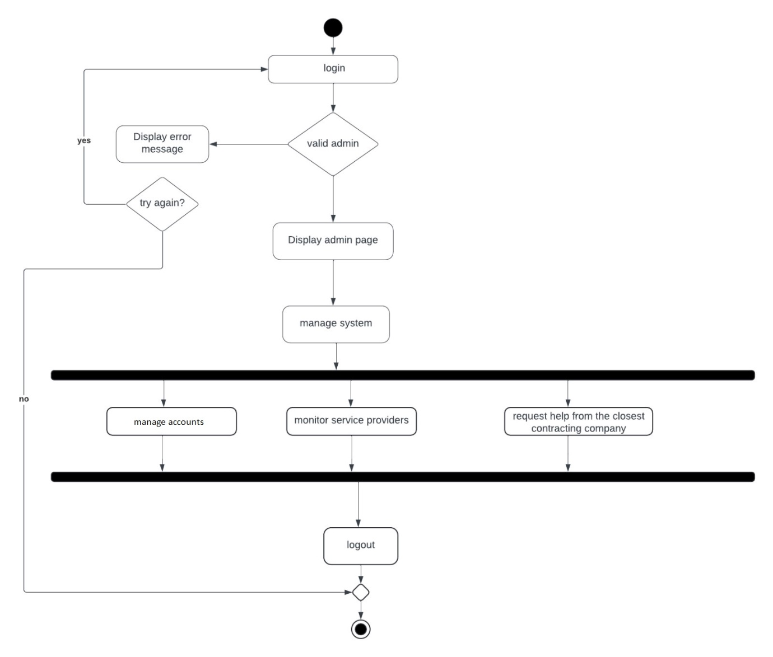

Figure 12 Admin Activity Diagram

Refer to Figure 12 to understand the comprehensive range of administrative activities and their coordination within the SafeSignal System.

* + **Employee Activity Diagram:**

Focusing on the employee's perspective, this diagram illustrates the sequence of activities undertaken by service providers from receiving a service request to fulfilling it.

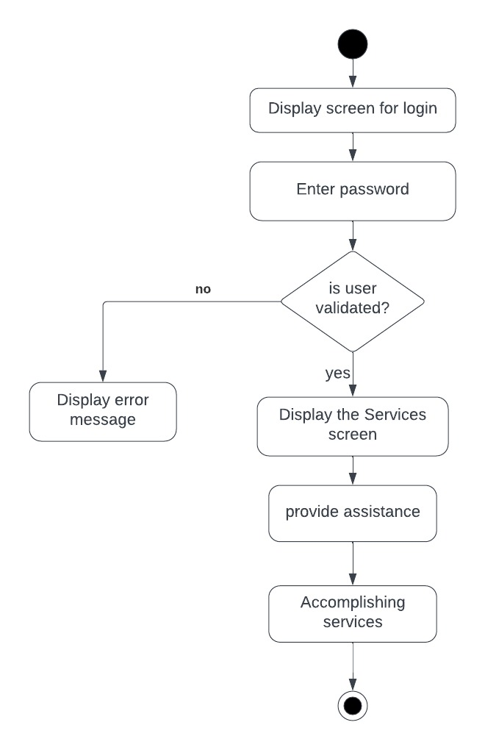

Figure 13 Employee Activity Diagram

Figure 13 delineates the activities performed by employees, highlighting the operational flow from task assignment through to service completion and reporting.

* + **Client Activity Diagram:**

The client activity diagram elucidates the processes a client engages with, from service discovery through to the service engagement and feedback loop.

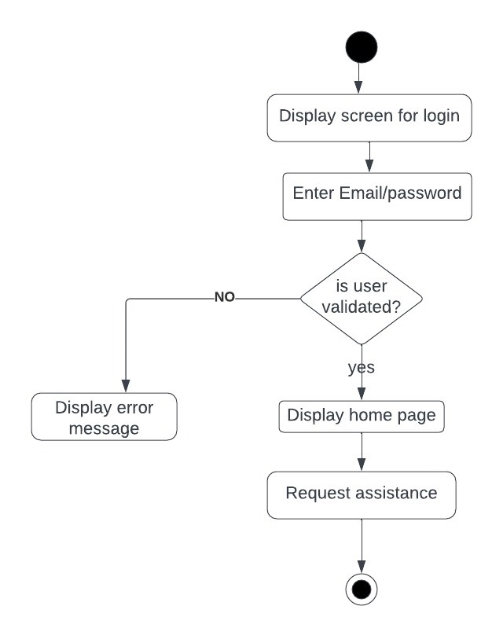

Figure 14 Client Activity Diagram

Figure 14 presents the activity flow for clients, detailing the steps involved in accessing and utilizing the services offered by the SafeSignal System.

Through these activity diagrams, we illuminate the comprehensive workflow and coordination of activities essential to the SafeSignal System's service delivery. By meticulously mapping out the processes relevant to Clients, Admins, and Employees, we foster a deep comprehension of the system's functional orchestration. This approach not only accentuates our commitment to a user-focused and efficient system design but also strategically informs the subsequent stages of development and implementation, ensuring the SafeSignal System is primed for operational excellence and user satisfaction.

## Entity-Relationship (ER) Diagrams

Entity-relationship diagrams serve as the backbone for understanding the structure of the database that supports the SafeSignal System. These diagrams visually represent the entities within the system, the relationships among them, and the attributes of both entities and relationships. ERDs are crucial for designing a database that is capable of storing and managing the data needed for the system’s operations effectively.

For the SafeSignal System, the ER Diagram is developed to encapsulate the complexity of data interactions and relationships critical for facilitating urban mobility and roadside assistance services. This diagram illustrates the system's ability to manage user data, service requests, transaction records, feedback, and other essential information.

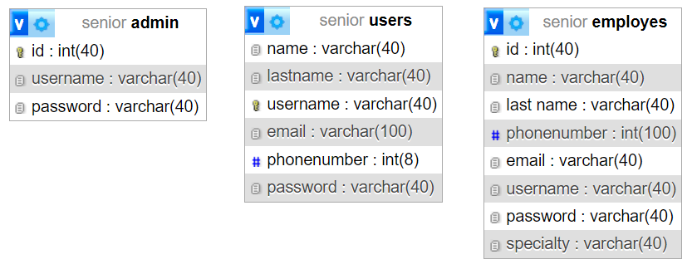

Figure 15 SafeSignal System ER Diagram

This diagram provides a clear visualization of the data organization and relationships within the SafeSignal System. It includes entities such as Users, Services, Feedback, and more, each linked by relationships that define how data flows and is interconnected within the system, Refer to Figure 15.

Through this ER Diagram, we present a structural blueprint of the SafeSignal System's data organization, underscoring our commitment to a robust and comprehensive system design. This graphical representation not only aids in the technical development of the database but also provides stakeholders with a clear understanding of how data is managed and utilized to deliver seamless and efficient services.

## Non-Technical Aspects

### Financial Viability

A cost benefit analysis of the project. Here is an example

In assessing the financial viability of the SafeSignal System, a detailed cost-benefit analysis was undertaken. The following Table 4illustrates the items considered in the analysis along with their associated costs and benefits:

|  |  |  |
| --- | --- | --- |
| **Item** | **Description** | **Amount (USD)** |
| Tow Truck | Cost per usage of the tow truck service provided by an external company | - |
| Motorcycle Services | Cost per usage of the motorcycle services provided by external company | - |
| Mechanician Services | Cost per usage of the mechanical services provided by an external company | - |
| Fuel Delivery | Cost per usage of the fuel delivery service provided by an external company | - |
| Increased Revenue | Anticipated revenue generated from platform usage. | +50,000$ |
| Quality Increase Revenue | Revenue enhancement due to improved service quality. | +7,500$ |
| Reduced material costs | Savings resulting from streamlined material usage. | +3,000$ |
| Reduced Labor Costs | Cost reductions attributed to optimized labor utilization. | +10,000$ |
| Purchase of Machine | The initial investment in acquiring necessary machinery. | -14,000$ |
| Installation of Machine | Expenses associated with installing and setting up machinery. | -5,000 |
| New Operator | Hiring costs for new personnel to operate the system. | -6,000$ |
| Utilities | Ongoing expenditures related to utilities required for system operation. | -2,500$ |
| Insurance | Insurance premiums to safeguard against potential risks. | -3,500$ |
| Square footage | Costs are linked to the physical space occupied by the system. | -1,500$ |

Table 4 Cost Benefit Analysis

This comprehensive breakdown provides insights into both the anticipated benefits and associated costs, facilitating a thorough evaluation of the project's financial viability.

### Stakeholders

Stakeholders are pivotal in ensuring the success and effectiveness of the SafeSignal System, encompassing those who benefit from the services, those potentially impacted, and those with decision-making authority.

* + **Beneficiaries:**
    - **Users:** Individuals seeking prompt assistance during roadside emergencies, including commuters, drivers, and travelers.
    - **Local Businesses:** Partnering towing companies, motorcycle service providers, mechanic teams, and fuel delivery services may witness increased demand and business opportunities.
    - **Local Authorities**: Improved traffic flow and reduced congestion can benefit city administrations by enhancing overall urban mobility.
    - **Community:** Enhanced accessibility and reduced travel times contribute to a better quality of life for residents.
  + **Potentially** **Affected:**
    - **Traditional Service Providers:** Existing towing companies, motorcycle repair shops, mechanics, and fuel stations might experience shifts in market demand and competition due to the introduction of specialized assistance services.
    - **Independent Contractors:** Freelance tow truck drivers, mechanics, and fuel delivery agents may face challenges in adapting to changes in the industry landscape and market dynamics.
  + **Decision-Makers:**
    - **Project Managers:** Oversight and coordination of service implementation, performance monitoring, and quality assurance.
    - **Government Regulatory Bodies:** Regulatory authorities responsible for licensing, safety standards enforcement, and policy development in the transportation sector.
    - **Service Providers:** Contracted companies delivering tow truck, motorcycle, mechanic, and fuel delivery services, contributing expertise and resources to ensure efficient service delivery.
    - **End Users:** Feedback and input from users play a vital role in refining service offerings, addressing concerns, and enhancing overall user experience.

Collaboration and engagement with these stakeholders are essential for the successful deployment and operation of the SafeSignal System, fostering a mutually beneficial ecosystem that prioritizes safety, efficiency, and customer satisfaction.

### Scope

Exactly what will be done in the project, sometimes it is helpful to state what will not be done in the project.

The scope of the project encompasses the development and implementation of the SafeSignal System, focusing on the following key aspects:

* + **Tow Truck Service:** Integration of a tow truck service allowing users to request assistance for vehicle towing in case of breakdowns or accidents.
  + **Motorcycle Assistance Service:** Provision of motorcycle-based assistance for users experiencing traffic congestion or seeking quick navigation through crowded areas.
  + **Mechanical Services**: Users can access on-demand mechanical teams through the app to address minor vehicle faults or maintenance issues, providing assistance wherever they are stranded, be it on the road or elsewhere.
  + **Fuel Delivery Service:** Through the app, users can request fuel delivery services when encountering fuel shortages or running out of fuel while on the road, ensuring convenient refueling options wherever they may be.

Additionally, the project scope includes:

* + Development of a user-friendly mobile application for seamless service accessibility and interaction and a web platform to inform about our company and our services.
  + Integration with external service providers to facilitate the provision of tow truck, motorcycle assistance, mechanical, and fuel delivery services.
  + Implementation of a secure payment system to facilitate transactions for service usage.
  + Testing and validation of the system to ensure reliability, efficiency, and user satisfaction.
  + Deployment of appropriate marketing and promotional strategies to attract users and increase platform adoption.

What's not included?

* + Physical operation of tow trucks, motorcycles, mechanical teams, or fuel delivery vehicles; these services will be provided by external companies.

Manufacturing or procurement of vehicles and equipment required for service provision.

* + Regulatory compliance and licensing for the operation of external service providers; this responsibility lies with the respective companies.
  + Long-term maintenance and support of vehicles and equipment used by external service providers; routine maintenance and repairs are the responsibility of the service providers.

This delineation of project scope provides clarity on the deliverables, responsibilities, and limitations of the SafeSignal System project.

### Risks

Things that may stop the project from achieving the goals in the scope.

The successful implementation of the SafeSignal System hinges on various factors, including proactive identification and mitigation of potential risks. Below are key risk factors that may pose challenges to achieving the project's scope and objectives.

* + **Technical Challenges**: Unforeseen technical difficulties or limitations in implementing the required features and functionalities of the SafeSignal System could hinder project progress.
  + **Market Competition:** Intense competition from existing urban mobility solutions or new entrants into the market may pose a challenge to gaining market share and user adoption.
  + **Regulatory Hurdles:** Adverse changes in regulations or legal requirements related to transportation services could impact the operation and compliance of the system.
  + **Financial Constraints:** Insufficient funding or budgetary constraints may restrict the ability to execute planned activities or invest in necessary resources for system development and maintenance.
  + **Technological Dependency**: Reliance on third-party technologies or services for certain system functionalities could expose the project to risks associated with service disruptions, changes in pricing, or compatibility issues.
  + **User Acceptance:** Lack of acceptance or resistance from potential users to adopt the SafeSignal System may impede its success and hinder the achievement of project goals.
  + **Operational Challenges:** Operational inefficiencies, logistical complexities, or staffing issues could affect the smooth functioning and delivery of services through the system, impacting user experience and satisfaction.

### Schedule and Milestones

The below Table 5 is the projected timeline outlining the tasks and milestones for the development of the SafeSignal System:

|  |  |  |  |  |
| --- | --- | --- | --- | --- |
| **Task** | **Start Date** | **End Date** | **Task Durations** | **Weeks** |
| Project Definition | 20 Feb | 7 Mar | 14 days | 1-3 |
| Searching for ideas | 20 Feb | 5 Mar | 14 days | 1-2 |
| Approving Ideas and Plans | 6 Mar | 13 Mar | 7 days | 2-3 |
| Reporting | 8 Mar | 4 Mar | 49 days | 3-9 |
| Chapter 1 (Introduction, Problem Statement) | 8 Mar | 15 Mar | 7 days | 3-4 |
| Chapter 2 (Similar Systems) | 16 Mar | 24 Mar | 7 days | 4-5 |
| Chapter 3 (Diagrams, Overview, Study) | 25 Mar | 7 Apr | 14 days | 5-7 |
| Chapter 4 (Implementation Parts) | 8 Apr | 15 Apr | 7 days | 7-8 |
| Chapter 5 (Conclusion, Future Work) | 17 Apr | 25 Apr | 7 days | 8-9 |

Table 5 Scheduling Tasks and Milestones

This schedule delineates the tasks and their respective durations, providing a structured plan for the completion of the project within the specified timeline.

### Ethical and Social Considerations

In considering the ethical and social dimensions of the SafeSignal System, several key factors must be addressed to ensure responsible and equitable service delivery.

* + **Privacy Protection:** Ensuring the confidentiality and privacy of user data collected through the SafeSignal System to prevent unauthorized access or misuse.
  + **Fair Treatment:** Implementing fair and non-discriminatory practices in service provision, ensuring equal access and treatment for all users regardless of their background or identity.
  + **Transparency**: Providing clear and transparent information to users regarding the collection, storage, and usage of their data to build trust and accountability.
  + **Safety and Security:** Prioritizing the safety and security of users and employees involved in the delivery of services, including implementing measures to mitigate risks such as accidents, theft, or fraud.
  + **Accessibility:** Designing the system to be accessible and inclusive for individuals, ensuring that they can effectively utilize the services offered.
  + **Environmental Impact:** Minimizing the environmental footprint of the system's operations by promoting eco-friendly practices and reducing carbon emissions associated with transportation activities.
  + **Community Engagement:** Engaging with local communities and stakeholders to address concerns, gather feedback, and ensure that the system's implementation aligns with community values and needs.
  + **Ethical Use of Technology:** Employing technology ethically and responsibly, avoiding the use of algorithms that may perpetuate biases or discrimination against certain groups.
  + **Corporate Social Responsibility:** Integrating principles of corporate social responsibility into the project's objectives and operations, including initiatives to give back to the community or support social causes.
  + **Cultural Sensitivity:** Respecting cultural norms, customs, and sensitivities in service delivery, particularly in diverse urban settings where users may come from different cultural backgrounds.

### Environmental and Sustainability Considerations

Given the nature of the SafeSignal System, there are minimal environmental impacts associated with its implementation. The primary operations of the system involve facilitating roadside assistance services, such as tow truck services, mechanical services, and fuel delivery, to users in need. These services are aimed at addressing immediate transportation issues and do not directly contribute to environmental degradation.

However, it is essential to consider potential indirect environmental impacts that may arise from the operation of vehicles involved in providing these services. This includes fuel consumption, vehicle emissions, and the generation of waste materials from vehicle maintenance activities. While these impacts are relatively small-scale and localized, efforts can be made to minimize them through the adoption of environmentally friendly practices by service providers.

Overall, while the SafeSignal System itself may not have a significant environmental footprint, there is an opportunity to integrate sustainable practices into its operation to mitigate any potential negative impacts and promote environmental stewardship.

### Relevant Standards

List the technical (and possibly the non-technical) standards that are relevant to your design. Examples are the WiFi standard (IEEE) and International Standardization Organization (ISO).

In designing the SafeSignal System, it's important to adhere to relevant technical and non-technical standards to ensure compatibility, safety, and quality of service. Some key standards to consider include:

* + **Technical Standards**
    - **IEEE Standards for Wireless Communication:** Since the platform likely involves a mobile app or web-based service for users to request assistance, adhering to IEEE standards such as IEEE 802.11 for Wi-Fi can ensure robust and secure wireless communication.
    - **ISO/IEC 27001 for Information Security Management:** Given the handling of personal user data and the potential risks of identity theft and fraud, this international standard can help in implementing an effective information security management system (ISMS).
    - **Payment Card Industry Data Security Standard (PCI DSS):** If the platform processes payments for services like car rental, sales, or fuel delivery, complying with PCI DSS is crucial for securing credit card transactions.
  + **Non-Technical Standards**
    - **Customer Service Excellence (CSE) Standards:** Implementing these standards can enhance user satisfaction by ensuring high-quality, responsive customer service across all services.
    - **Occupational Safety and Health Administration (OSHA) Recommendations:** Prioritizing the safety of our personnel, particularly those navigating busy streets or performing auto maintenance, following OSHA's directives is essential to reduce the risk of injuries and accidents.
    - **Fair Trading Acts and Consumer Protection Laws:** Ensuring compliance with local and international consumer protection laws can safeguard service against legal challenges and promote trustworthiness among users.

## Conclusion

In conclusion, this chapter has provided a comprehensive overview of the various aspects related to the development and implementation of the SafeSignal System. We began by exploring the existing methods and similar systems, highlighting their features, strengths, and shortcomings. Through a comparative analysis, we identified key areas for improvement and innovation in our proposed system.

The system design phase was discussed in detail, outlining the requirements, specifications, and architectural considerations. Various diagrams were presented to visualize the system's structure and functionality. Additionally, non-technical aspects such as financial viability, stakeholders, scope, risks, and ethical considerations were carefully examined to ensure a holistic approach to system development.

Furthermore, the implementation, simulation, and testing phases were outlined, emphasizing the tools and methodologies employed to bring the system to fruition. Test cases and acceptance criteria were defined to validate the system's performance and functionality.

# Implementation/Simulation and Testing

## Introduction

Embarking on the practical journey of the SafeSignal project, this chapter narrates the intricate process of turning conceptual ideas into a working, operational system. We detail the transition from the static diagrams and theoretical concepts explored in earlier chapters to the hands-on development and validation of the system. This story is more than just about coding and software creation; it represents a saga of problem-solving, flexibility, and technical prowess required to materialize SafeSignal.

The sections that follow dive into the specifics of our implementation strategy, showcasing the tools and technologies leveraged, as well as the simulation methods utilized to mimic real-life scenarios. We also outline the testing protocols implemented to ensure the system's performance, dependability, and security align with our ambitious goals.

By the conclusion of this chapter, readers will have a thorough understanding of the meticulous steps undertaken to guarantee the SafeSignal system is not only operational but also sturdy and intuitive, poised to cater to the needs of its prospective users.

## Implementation Tools

For the development of the SafeSignal system, we carefully selected a suite of development tools, platforms, and frameworks known for their dependability, extensive community support, and compatibility with our project objectives. Presented below is an exhaustive inventory of the tools utilized in crafting the SafeSignal mobile application:

* + **Hardware:**
    - **Development Workstations:** Essential for the software development process, these high-capacity computers were equipped with significant RAM and powerful processors, facilitating efficient code compilation, application development, and rigorous simulations.
    - **Android Testing Devices:** To guarantee SafeSignal delivers a uniform user experience across various devices, we tested the app on a diverse assortment of Android smartphones and tablets, each with distinct screen dimensions and hardware configurations.
  + **Software:**
    - **Integrated Development Environment (IDE):** Android Studio played a pivotal role as our primary development tool, providing an advanced code editor, debugging capabilities, and extensive lifecycle support for the application.
    - **Compilers:** Integrated with Android Studio, the Android SDK was utilized to compile our code into executable application files for Android devices.
    - **Frameworks:** Utilizing the comprehensive libraries available within the Android SDK, we designed SafeSignal's user interface, and implemented database interactions.
    - **CASE Tools:** During the design stage, UML tools were employed to generate detailed diagrams that accurately represented the system's architecture, ensuring a clear and structured framework for our development process.
    - **Database Management with XAMPP:** XAMPP offered a local server environment, enabling the management of a MySQL database crucial for SafeSignal. This tool was instrumental in handling database operations and streamlining the development and testing of database functionalities essential to the application.

The combination of Android Studio and XAMPP established a highly effective development ecosystem for the SafeSignal project. Each tool played a critical role not only in the seamless transition from conceptual design to the final product but also in achieving the high quality and functional performance we aspired to.

## Implementation Summary

Description of detailed implementation steps. Demonstrate the typical code fragments (details of implementation, e.g. source code listings must be included in an appendix and saved on an accompanying CD/DVD)

## 

## Test Cases and Acceptance Criteria

Describe the test cases used and the acceptance criteria.

## Conclusion

This paragraph in meant to draw conclusions highlighting the main ideas in this chapter.

# Conclusion and Future Work

## Conclusion

Any concluding remarks, lesson learned, etc…

The decision to undertake a new project is a challenge to prove the skill of individuals in the project and highlight the merit and ability of each person working on our SafeSignal application was not an easy way, as we faced some problems but decided to challenge any difficulty that might hinder our work.

The project involves designing and developing a comprehensive system that caters to various user roles, provides essential management functionalities, facilitates service provisioning and assistance, and ensures security and user satisfaction. Effective implementation of the project requires careful consideration of user requirements, system architecture, security measures, and performance optimization techniques.

Our project is a distinctive and new idea, especially in our country, Lebanon, as it helps people move around and arrive faster. The SafeSignal application is an application that aims to help people, provide job opportunities, and serve the customer in an ideal way. What distinguishes is that there are many types of services, namely Motorcycle Assistance Service, Car Towing, Roadside Support Service, and Fuel Delivery Service.

It was difficult at first because the project was rather complex, but with time and hard work, we developed this mobile application. We learned a lot of new things such as dealing with more complex codes, in addition to learning more about the database and its usefulness as it deals with large amounts of data. While working on our project, we realized that paying attention to every detail is essential to developing a perfect mobile application.

Working hard and doing your best with your partners to improve your mobile application, we were ready to finish our project on time, which is good as a first step in our future career.

## Future Work

Describe the opportunities for expanding the work done in this thesis.

Looking ahead, the SafeSignal application stands on the brink of several exciting developmental prospects. The journey thus far has laid a solid foundation, yet the path forward is rife with opportunities to broaden the scope and enhance the efficacy of the application.

Firstly, our commitment to elevating the user experience (UX) remains unwavering. The next phase will involve extensive user testing and feedback collection to unearth areas ripe for enhancement. This endeavor aims to refine both the app's interface and its overall functionality. Embracing responsive design principles will ensure a seamless and intuitive experience across diverse devices and screen sizes. Moreover, enriching the application with advanced interaction features such as gesture-based navigation and voice commands.

Secondly, the integration of emerging technologies such as Artificial Intelligence (AI) and Machine Learning (ML) opens a new frontier for app functionality and personalization. These technologies can be harnessed to predict user preferences, offer tailored recommendations, and automate routine tasks, thereby elevating the overall user experience. Furthermore, an unwavering focus on cybersecurity measures, including the continuous monitoring of vulnerabilities, robust encryption protocols, and adherence to industry standards, will fortify the app's defenses against evolving cyber threats.

Thirdly, the expansion of service offerings presents a vast growth potential. In addition to the existing features, introducing new services like Car Rental and Sales Service and Learn to Drive Service will address a wider range of user needs and preferences. These services will not only enhance the utility of SafeSignal but also position it as a comprehensive solution for diverse mobility requirements.

By focusing on these strategic areas of development, SafeSignal aims to not only refine its existing capabilities but also broaden its service offerings. This forward-looking approach is geared towards delivering exceptional value to users, ensuring SafeSignal's enduring relevance and competitiveness in the ever-evolving mobile app market.

**APPENDIX A:   
Implementation Details**

Any details not fit in chapter 5: e.g. detailed calculation, complex algorithms, etc…

**APPENDIXB:  
 USER Manual**

Fill in the instruction manual for using the application

**APPENDIXC:   
deployment and configuration Manual**

Outline the deployment and configuration details in addition to any know troubleshooting techniques.

**REFERENCES**

|  |  |
| --- | --- |
| [1] | John Smith and John Doe, "Wireless Sensor Networks," *IEEE Transaction on Mobile Computing ,* vol. 1, no. 2, p. 12, 05 2010. |
| [2] | John Smith et al., How to add IEEE Reference style to Microsoft Word, Beirut, Lebanon: LIU, 2011. |